PROGRAM DEFINITION
- A program to print a report for a list of LOOs that need to be followed up on or have succeeded in becoming Letter of Consent (LOC)

RELATED TABLES
Access

ROLES
Test
- User that has access to program

INITIAL PROCESS
Test
- Set VAR_COMPANY_ID = Login User’s Company ID
- Set VAR_USER_ID = Login User ID
- Set VAR_LANGUAGE_ID = Login User’s Language ID
- Execute this stored procedure, save the results to VAR_YEAR_RANGE
EXEC RSP_GS_GET_PERIOD_YEAR_RANGE
VAR_COMPANY_ID
, ''
, ''
- Set VAR_LOOKUP_DEPARTMENT_LIST_GET_RECORD = Value from lookup GSL00700 with the following parameters:
- VAR_COMPANY_ID
- VAR_USER_ID
- ‘’
- Set VAR_LOOKUP_SALESMAN_LIST_GET_RECORD = Value from lookup PML00500 with the following parameters:
- VAR_COMPANY_ID
- selected Property ID
- VAR_USER_ID
- -

MAIN FORM

USER INTERFACE

INITIAL VERSION
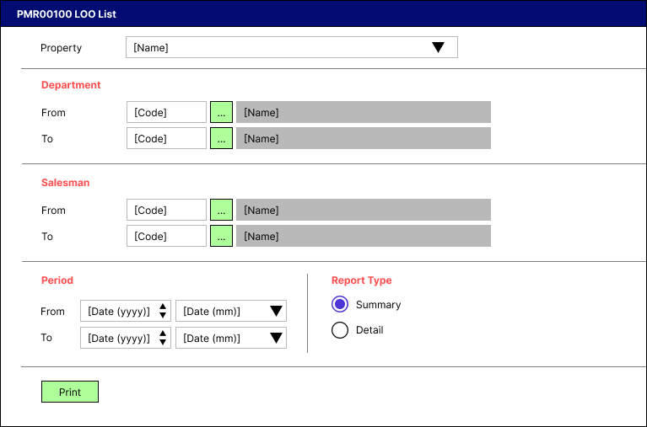

BUTTON DEFINITION
Button Name | Action
Print | Run PRINT REPORT PROCESS

DISPLAY PROCESS

FIELD DEFINITION
Name | Field | Type | Validation
Property |  | Combo box  Set VAR_PROPERTY_LIST with  EXEC RSP_GS_GET_PROPERTY_LIST  VAR_COMPANY_ID  , VAR_USER_ID  Set property id = CPROPERTY_ID  Set property name = CPROPERTY_NAME  Set default selected property id = top 1 property id from VAR_PROPERTY_LIST.  Show name from the specific property id | - Mandatory  - -
Department [From [Code]] |  | Text box | - Mandatory  - If user inputs manually, then check its name based on VAR_LOOKUP_DEPARTMENT_LIST_GET_RECORD and save it to VAR_DEPARTMENT_NAME. Finally:  - If VAR_DEPARTMENT_NAME is empty, then:  - Display message “Department [INPUT Department Code] not found!”, [OK]  - Set focus to Department [From [Code]] field  - Else, set Department [From [Name]]’s value = VAR_DEPARTMENT_NAME  - -
Department [From [Lookup]] |  | Lookup | - Enter lookup program GSL00700 with parameters:  - VAR_COMPANY_ID  - VAR_USER_ID  - ‘’  Then save the result to VAR_DEPARTMENT_RESULT  - If VAR_DEPARTMENT_RESULT is empty, then:  - Display message “Department [INPUT Department Code] not found!”, [OK]  - Set focus to Department [From [Code]] field  - Else if VAR_DEPARTMENT_RESULT exists, then:  - Set Department [From [Code]] = CDEPT_CODE  - Set Department [From [Name]] = CDEPT_NAME  - -
Department [From [Name]] |  | Text box | - Disabled  - -
Department [To [Code]] |  | Text box | - Mandatory  - If user inputs manually, then check its name based on VAR_LOOKUP_DEPARTMENT_LIST_GET_RECORD and save it to VAR_DEPARTMENT_NAME. Finally:  - If VAR_DEPARTMENT_NAME is empty, then:  - Display message “Department [INPUT Department Code] not found!”, [OK]  - Set focus to Department [To [Code]] field  - Else, set Department [To [Name]]’s value = VAR_DEPARTMENT_NAME  - -
Department [To [Lookup]] |  | Lookup | - Enter lookup program GSL00700 with parameters:  - VAR_COMPANY_ID  - VAR_USER_ID  - ‘’  Then save the result to VAR_DEPARTMENT_RESULT  - If VAR_DEPARTMENT_RESULT is empty, then:  - Display message “Department [INPUT Department Code] not found!”, [OK]  - Set focus to Department [To [Code]] field  - Else if VAR_DEPARTMENT_RESULT exists, then:  - Set Department [To [Code]] = CDEPT_CODE  - Set Department [To [Name]] = CDEPT_NAME  - -
Department [To [Name]] |  | Text box | - Disabled  - -
Salesman [From [Code]] |  | Text box | - Mandatory  - If user inputs manually, then check its name based on VAR_LOOKUP_SALESMAN_LIST_GET_RECORD and save it to VAR_SALESMAN_NAME. Finally:  - If VAR_SALESMAN_NAME is empty, then:  - Display message “Salesman [INPUT Salesman Code] not found!”, [OK]  - Set focus to Salesman [From [Code]] field  - Else, set Salesman [From [Name]]’s value = VAR_SALESMAN_NAME  - -
Salesman [From [Lookup]] |  | Lookup | - Enter lookup program PML00500 with parameters:  - VAR_COMPANY_ID  - Selected Property Id  - VAR_USER_ID  Then save the result to VAR_SALESMAN_RESULT  - If VAR_SALESMAN_RESULT is empty, then:  - Display message “Salesman [INPUT Salesman Code] not found!”, [OK]  - Set focus to Salesman [From [Code]] field  - Else if VAR_SALESMAN_RESULT exists, then:  - Set Salesman [From [Code]] = CSALESMAN_ID  - Set Salesman [From [Name]] = CSALESMAN_NAME  - -
Salesman [From [Name]] |  | Text box | - Disabled  - -
Salesman [To [Code]] |  | Text box | - Mandatory  - If user inputs manually, then check its name based on VAR_LOOKUP_SALESMAN_LIST_GET_RECORD and save it to VAR_SALESMAN_NAME. Finally:  - If VAR_SALESMAN_NAME is empty, then:  - Display message “Salesman [INPUT Salesman Code] not found!”, [OK]  - Set focus to Salesman [To [Code]] field  - Else, set Salesman [To [Name]]’s value = VAR_SALESMAN_NAME  - -
Salesman [To [Lookup]] |  | Lookup | - Enter lookup program PML00500 with parameters:  - VAR_COMPANY_ID  - Selected Property Id  - VAR_USER_ID  Then save the result to VAR_SALESMAN_RESULT  - If VAR_SALESMAN_RESULT is empty, then:  - Display message “Salesman [INPUT Salesman Code] not found!”, [OK]  - Set focus to Salesman [To [Code]] field  - Else if VAR_SALESMAN_RESULT exists, then:  - Set Salesman [To [Code]] = CSALESMAN_ID  - Set Salesman [To [Name]] = CSALESMAN_NAME  - -
Salesman [To [Name]] |  | Text box | - Disabled  - -
Period [From [Year]] |  | Spinner  Spinner value:  - Minimum = VAR_YEAR_RANGE.IMIN_YEAR  - Maximum = VAR_YEAR_RANGE.IMAX_YEAR  Set default spinner value:  SELECT YEAR(dbo.RFN_GET_DB_TODAY (VAR_COMPANY_ID)) | - Mandatory  - -
Period [From [Month]] |  | Combo box  Set VAR_PERIOD_MONTH_LIST (as array of object) with VAR_MONTH_NUMBER and VAR_MONTH_NAME.  Set VAR_MONTH_NUMBER = 01, 02, … , 12  Set VAR_MONTH_NAME = January, February, … , December  Set default combo box value month name based on  SELECT MONTH(dbo.RFN_GET_DB_TODAY (VAR_COMPANY_ID)) | - Mandatory  - -
Period [To [Year]] |  | Spinner  Spinner value:  - Minimum = VAR_YEAR_RANGE.IMIN_YEAR  - Maximum = VAR_YEAR_RANGE.IMAX_YEAR  Set default spinner value:  SELECT YEAR(dbo.RFN_GET_DB_TODAY (VAR_COMPANY_ID)) | - Mandatory  - -
Period [To [Month]] |  | Combo box  Set VAR_PERIOD_MONTH_LIST (as array of object) with VAR_MONTH_NUMBER and VAR_MONTH_NAME.  Set VAR_MONTH_NUMBER = 01, 02, … , 12  Set VAR_MONTH_NAME = January, February, … , December  Set default combo box value month name based on  SELECT MONTH(dbo.RFN_GET_DB_TODAY (VAR_COMPANY_ID)) | - Mandatory  - -
Report Type |  | Radio button  Radio Value  - ‘1’ = Summary  - ‘2’ = Detail  Set default value to Summary | - Mandatory  - -

PRINT REPORT PROCESS

REPORT LAYOUT
PAPER SIZE: A4 LANDSCAPE
FONT SIZE: 7
REPORT TYPE: SUMMARY CR01
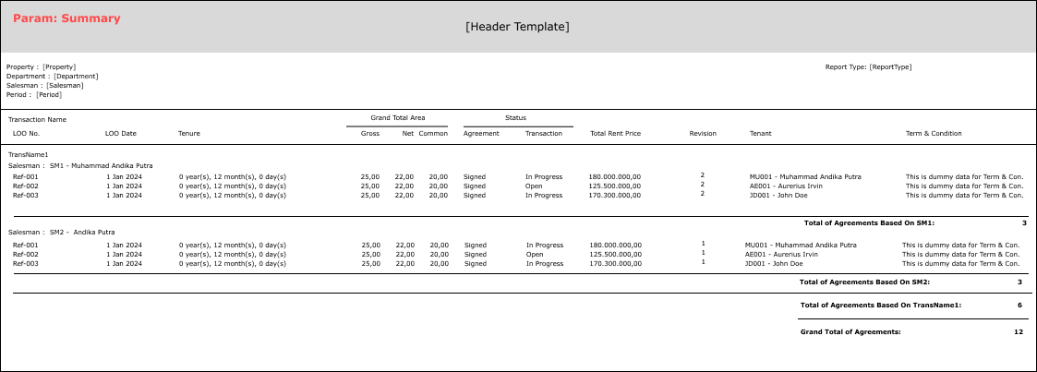

PAPER SIZE: A4 LANDSCAPE
FONT SIZE: 7
REPORT TYPE: DETAIL CR01 CR02
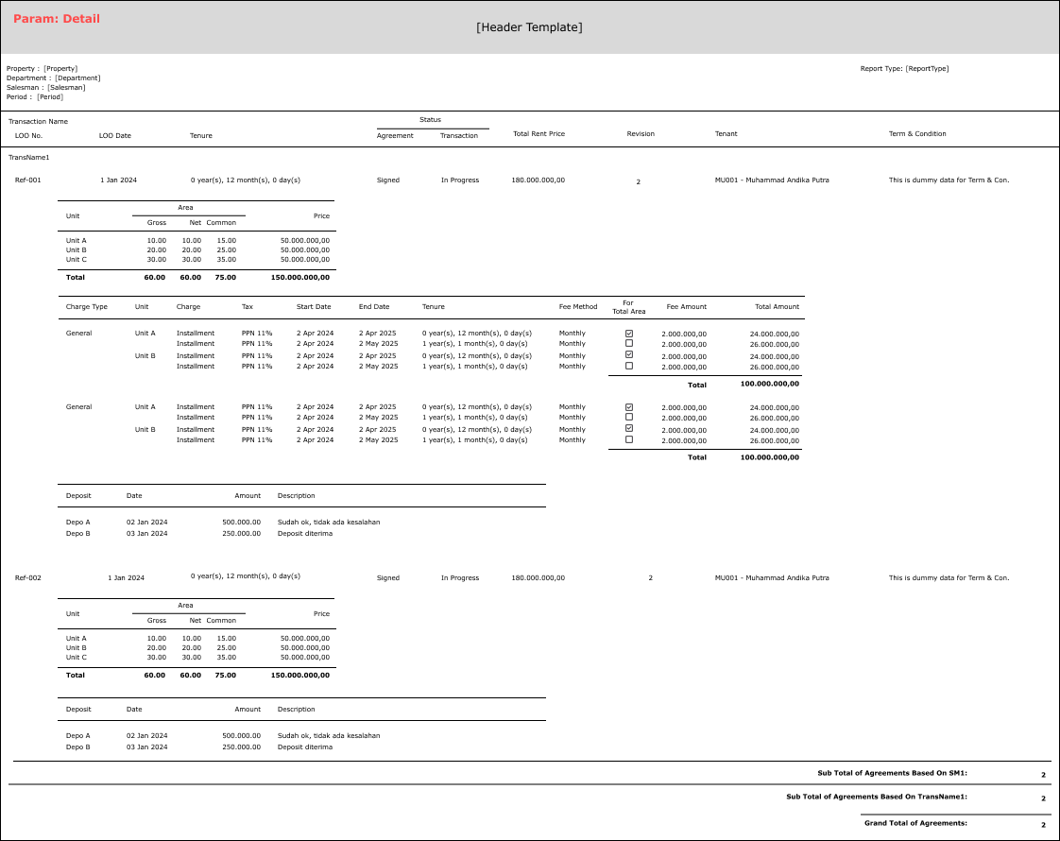

REPORT DEFINITION
REPORT SECTION FOR HEADER (IN GENERAL)
Section | Name | Field | Validation
HEADER | Property | Selected Property | Show Property ID – Property Name  Ex. “ABCDE – Global Property”
 | Department | Selected Department | IF Department [From [Code]] <> Department [To [Code]], then “Department [From [Name]] (Department [From [Code]]) – Department [To [Name]] (Department [To [Code]])”  ELSE, “Department [From [Name]] (Department [From [Code]])”  Ex. 1  Selected from: MNY – Department Keuangan  Selected to: ITSI – Department Sistem Informasi  Hence, show “Department Keuangan (MNY) – Department Sistem Informasi (ITSI)”  Ex. 2  Selected from: ITSI – Department Sistem Informasi  Selected to: ITSI – Department Sistem Informasi  Hence, show “Department Sistem Informasi (ITSI)”
 | Salesman | Selected Salesman | IF Salesman [From [Code]] <> Salesman [To [Code]], then “Salesman [From [Name]] (Salesman [From [Code]]) – Salesman [To [Name]] (Salesman [To [Code]])”  ELSE, “Salesman [From [Name]] (Salesman [From [Code]])”  Ex. 1  Selected from: MU01 – Andika Putra  Selected to: AE01 – Aurerius Irvin  Hence, show “Andika Putra (MU01) – Aurerius Irvin (AE01)”  Ex. 2  Selected from: MU01 – Andika Putra  Selected to: MU01 – Andika Putra  Hence, show “Andika Putra (MU01)”
 | Period | Selected Period | If Period [From] <> Period [To], then show “MMM yyyy – MMM yyyy”  Ex. Period [From] = “200109” and Period [To] = “200110”, then show “September 2001 – October 2001”  Else, show “MMM yyyy"  Ex. Period [From] = “200109” and Period [From] = “200109”, then show “September 2001”
 | Report Type | Selected Report Type | Show Report Type’s value  Ex. “Summary”

REPORT SECTION FOR SUMMARY
Section | Name | Field | Validation
REPORT GROUP | Transaction | CTRANS_CODE
 | Salesman | CSALESMAN_ID
GROUP BY TRANSACTION [HEADER] | Transaction Name | CTRANS_NAME
GROUP BY SALESMAN [HEADER] | Salesman | CSALESMAN_ID - CSALESMAN_NAME
DETAIL | LOO No. | CREF_NO
 | LOO Date | CREF_DATE
 | Tenure | CTENURE
 | Grand Total Area (Gross) | NTOTAL_GROSS_AREA_SIZE
 | Grand Total Area (Net) | NTOTAL_NET_AREA_SIZE
 | Grand Total Area (Common) | NTOTAL_COMMON_AREA_SIZE
 | Agreement Status | CAGREEMENT_STATUS_NAME
 | Transaction Status | CTRANS_STATUS_NAME
 | Total Rent Price | NTOTAL_PRICE
 | Tax | CTAX CR01
 | Revision | NREVISION_COUNT
 | Tenant | CTENANT_ID - CTENANT_NAME
 | Term & Condition | CTC_MESSAGE
GROUP BY SALESMAN [FOOTER] | Sub Total of Agreement |  | Count of CREF_NO
GROUP BY TRANSACTION [FOOTER] | Sub Total of Agreement |  | Count of CREF_NO
SUMMARY | Grand Total of Agreement |  | Count of CREF_NO

REPORT SECTION FOR DETAIL
Section | Name | Field | Validation
REPORT GROUP | Transaction | CTRANS_CODE
 | Salesman | CSALESMAN_ID
 | LOO No. | CREF_NO
GROUP BY TRANSACTION [HEADER] | Transaction Name | CTRANS_NAME
GROUP BY SALESMAN [HEADER] | Salesman | CSALESMAN_ID - CSALESMAN_NAME
GROUP BY LOO NO. [HEADER] | LOO No. | CREF_NO
 | LOO Date | CREF_DATE
 | Tenure | CTENURE
 | Agreement Status | CAGREEMENT_STATUS_NAME
 | Transaction Status | CTRANS_STATUS_NAME
 | Total Rent Price | NTOTAL_PRICE
 | Tax | CTAX CR01
 | Revision | NREVISION_COUNT
 | Tenant | CTENANT_ID - CTENANT_NAME
 | Term & Condition | CTC_MESSAGE
DATA UNIT [HEADER] | - | - | If (CUNIT_DETAIL_ID is null), then suppress the section
DATA UNIT [DETAIL] | Unit | CUNIT_DETAIL_ID - CUNIT_DETAIL_NAME | If (CUNIT_DETAIL_ID is null), then suppress the section  For this Section, use a Data Transfer Object, named VAR_DTO_UNIT with the following groups:  - CTRANS_CODE  - CSALESMAN_ID  - CREF_NO  - CUNIT_DETAIL_ID
 | Gross Area | NUNIT_DETAIL_GROSS_AREA_SIZE
 | Net Area | NUNIT_DETAIL_NET_AREA_SIZ
 | Common Area | NUNIT_DETAIL_COMMON_AREA_SIZE
 | Rent Price | NUNIT_DETAIL_PRICE
DATA UNIT [FOOTER] | Total of Gross Area |  | If (CUNIT_DETAIL_ID is null), then suppress the section  Use Formula sum of DATA UNIT [DETAIL [NUNIT_DETAIL_GROSS_AREA_SIZE]]
 | Total of Net Area |  | Use Formula sum of DATA UNIT [DETAIL [NUNIT_DETAIL_NET_AREA_SIZE]]
 | Total of Common Area |  | Use Formula sum of DATA UNIT [DETAIL [NUNIT_DETAIL_COMMON_AREA_SIZE]]
 | Total of Price |  | Use Formula sum of DATA UNIT [DETAIL [NUNIT_DETAIL_PRICE]]
DATA CHARGE [HEADER] | Charge Type | CCHARGE_DETAIL_TYPE_NAME | If (CCHARGE_DETAIL_TYPE_NAME is null), then suppress the section  For this Section, use a Data Transfer Object, named VAR_DTO_CHARGE with the following groups:  - CTRANS_CODE  - CSALESMAN_ID  - CREF_NO  - CCHARGE_DETAIL_TYPE_NAME
DATA CHARGE [UNIT [HEADER]] | Unit | CCHARGE_DETAIL_UNIT_NAME | If (CCHARGE_DETAIL_TYPE_NAME is null), then suppress the section  For this Section, use a Data Transfer Object, named VAR_DTO_CHARGE_UNIT with the following groups:  - CTRANS_CODE  - CSALESMAN_ID  - CREF_NO  - CCHARGE_DETAIL_TYPE_NAME  - CCHARGE_DETAIL_UNIT_NAME
DATA CHARGE [UNIT [DETAIL]] | Charge | CCHARGE_DETAIL_CHARGE_NAME | If (CCHARGE_DETAIL_TYPE_NAME is null), then suppress the section
 | Tax | CCHARGE_DETAIL_TAX_NAME
 | Start Date | CCHARGE_DETAIL_START_DATE
 | End Date | CCHARGE_DETAIL_END_DATE
 | Tenure | CCHARGE_DETAIL_TENURE
 | Fee Method | CCHARGE_DETAIL_FEE_METHOD
 | For Total Area | LFOR_TOTAL_AREA CR02
 | Fee Amount | NCHARGE_DETAIL_FEE_AMOUNT
 | Total Amount CR02 | NCHARGE_DETAIL_CALCULATED_FEE_AMOUNT
DATA CHARGE [UNIT [FOOTER]] | - | - | If (CCHARGE_DETAIL_TYPE_NAME is null), then suppress the section
DATA CHARGE [FOOTER] | Total of Total Amount |  | If (CCHARGE_DETAIL_TYPE_NAME is null), then suppress the section  Use Formula sum of DATA CHARGE [HEADER [NCHARGE_DETAIL_CALCULATED_FEE_AMOUNT]]
DATA DEPOSIT [HEADER] | - | - | If (CDEPOSIT_DETAIL_ID is null), then suppress the section
DATA DEPOSIT [DETAIL] | Deposit | CDEPOSIT_DETAIL_ID | If (CDEPOSIT_DETAIL_ID is null), then suppress the section
 | Date | CDEPOSIT_DETAIL_DATE
 | Amount | NDEPOSIT_DETAIL_AMOUNT
 | Description | CDEPOSIT_DETAIL_DESCRIPTION
DATA DEPOSIT [FOOTER] | - | - | If (CDEPOSIT_DETAIL_ID is null), then suppress the section
GROUP BY LOO NO. [FOOTER] | - | - | If (CDEPOSIT_DETAIL_ID is null), then suppress the section
GROUP BY SALESMAN [FOOTER] | Sub Total of Agreement |  | Count of CREF_NO
GROUP BY TRANSACTION [FOOTER] | Sub Total of Agreement |  | Count of CREF_NO
FOOTER | Grand Total of Agreement |  | Count of CREF_NO

VALIDATION
Field | Condition | Validation Message
Property | Empty | Please select Property
Department | Department [From [Code]] is empty or Department [To [Code]] is empty | Please select Department
Salesman | Salesman [From [Code]] is empty or Salesman [To [Code]] is empty | Please select Salesman
Period | Period [From] is higher than Period [To] | Period (From) cannot be higher than Period (To)

ACTION
- Execute this stored procedure:
RSP_PMR00100_GET_REPORT
VAR_COMPANY_ID
, selected Property ID
, selected Department [From [Code]]
, selected Department [To [Code]]
, selected Salesman [From [Code]]
, selected Salesman [To [Code]]
, selected Period [From]
, selected Period [To]
, selected Report Type
, VAR_LANGUAGE_ID

Note for sending those parameters to execute the stored procedure above:
- Selected Period [From]’s value should be “yyyymm”
- Selected Period [To]’s value should be “yyyymm”
- Selected Report Type’s value should be either ‘1’ or ‘2’
- !IMPORTANT!: DIFFERENT SELECTED REPORT TYPE RESULTING IN DIFFERENT OUTPUT

- Ex. 1 for Summary
EXEC RSP_PMR00100_GET_REPORT
'RCD'
, 'JBMPC'
, 'HRD'
, 'HRD'
, 'Alvan'
, 'Alvan'
, '202401'
, '202412'
, '1'
, 'EN'

- Ex. 2 for Detail
EXEC RSP_PMR00100_GET_REPORT
'RCD'
, 'JBMPC'
, 'HRD'
, 'HRD'
, 'Alvan'
, 'Alvan'
, '202401'
, '202412'
, '2'
, 'EN'

- -

CR LIST

CR | Description | Notes
CR01 | - Hapus kolom tax di report  - Pindah posisi Informasi salesman  - Ganti Judul report header revision
CR02, CH  14 MAR 2025 | - Tambah For Total Area, LFOR_TOTAL_AREA  - Ganti Nama Kolom Calculated Fee Amount jadi Total Amount

TEMPLATE

VALIDATION
Field | Condition | Validation Message

ACTION

